**SOFTWARE ENGINEERING**

**(IT-314)**

**EVENT PLANNER APPLICATION**

Cost Estimation Document

Version 1.0

**Team no: 14**

**Instructor: Prof. Asim Banerjee**

**Team Mentor: K Hemantha**

**Date:6 April, 2016**

**Team Members**

|  |  |  |
| --- | --- | --- |
| **S.No** | **Name** | **ID** |
| 1. | Patel Yash | 201301008 |
| 2. | Patel Tej Naginbhai | 201301018 |
| 3. | Anavadiya Yash Kumar | 201301052 |
| 4. | Chauhan Dwimitra Dharmendra | 201301079 |
| 5. | Rahul Shashank Saranjame (Team Leader) | 201301101 |
| 6. | Fatnani Varun Kumarbhai | 201301152 |
| 7. | Nikita Jain | 201301155 |
| 8. | Karri Kiran Satish Reddy | 201301168 |
| 9. | Raman Kumar Douchaniya | 201301202 |

**Version History**

|  |  |  |
| --- | --- | --- |
| **Date** | **Version no.** | **Author(s)** |
| 6/04/2016 | 1.0 | Yash Anavadiya, Varun Fatnani |

**Table of Contents**

1. Overview...............................................................................................................4

2. COCOMO………………………………………………………………………..4

2.1 Cost Drivers……………………………………………………………..5

3. References……….………….................................................................................8

**Overview**

Software cost estimation is the process of predicting the amount effort required to build a software system. There are various techniques used in software cost estimation.

**COCOMO**

The Constructive Cost Model (COCOMO) is an algorithmic software cost estimation model. This method uses some equations and parameters, which have been derived from previous experiences about software projects for estimation. This is most widely used estimation model.

COCOMO has three variants. That are as follows:

1. Basic COCOMO
2. Intermediate COCOMO
3. Detailed COCOMO

We are using Intermediate COCOMO to estimate cost of our project. Intermediate COCOMO computes software development effort as function of program size and a set of "cost drivers" that include subjective assessment of Product, Hardware, Personnel and Project attributes. This extension considers a set of four "cost drivers", each with a number of sub-attributes:-

* Product attributes
  + Required software reliability
  + Size of application database
  + Complexity of the product
* Hardware attributes
  + Run-time performance constraints
  + Memory constraints
  + Volatility of the virtual machine environment
  + Required turnabout time
* Personnel attributes
  + Analyst capability
  + Software engineering capability
  + Applications experience
  + Virtual machine experience
  + Programming language experience
* Project attributes
  + Use of software tools
  + Application of software engineering methods
  + Required development schedule

The COCOMO equations take the form

**Effort Applied (E)** = a(KLOC)b (EAF) [ person-months ]

**Development Time (D)** = c(Effort Applied)d[months]

**People required (P)** = Effort Applied / Development Time [count]

where **E** is the effort applied in **person-months**, **KLoC** is the estimated number of thousands of delivered lines of code for the project, and **EAF** is Effective Adjustment Factor. Each of the 15 attributes receives a rating on a six-point scale that ranges from "very low" to "extra high".An effort multiplier from the table below(on page.5 ) applies to the rating. The product of all effort multipliers results in an EAF**.** The coefficients **a, b, c** and **d** are given in the next table.

|  |  |  |  |  |
| --- | --- | --- | --- | --- |
| **Software Project** | **a** | **b** | **c** | **d** |
| **Organic** | 3.2 | 1.05 | 2.5 | 0.38 |
| **Semi-Detached** | 3.0 | 1.12 | 2.5 | 0.35 |
| **Embedded** | 2.8 | 1.20 | 2.5 | 0.32 |

**Cost Drivers**

The EAF is used to tailor your estimate based on conditions of the development environment. For the basic model it is not used and just set to 1. For the intermediate model there are 15 different cost drivers that can be used to calculate your EAF. As we have listed them above in this document. They are being categorised in four groups; Product attributes, Hardware attributes, Personnel attributes, and Project attributes. Each cost driver is rated on a scale Very Low to Extra High depending on how that cost driver will affect your development.

To calculate the EAF from the cost drivers you simply choose values for each cost driver and multiply them all together. The resulting number is your EAF.

**Rating of Cost Drivers which helps in calculating EAF**.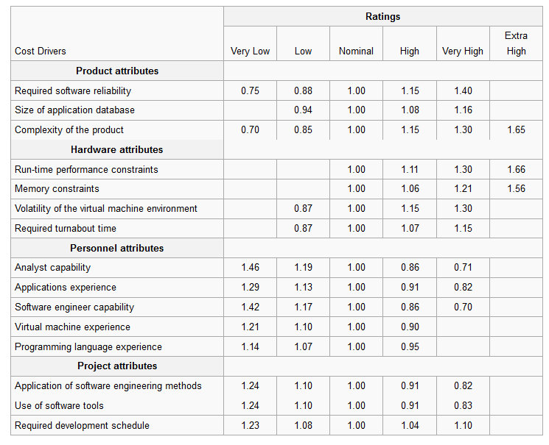

Now, we will calculate

Lines of code (LOC) = 3500

Kilo Lines of Code (KLOC) = 3.5

Estimated Team Effort Applied (E)

= a (KLOC)b * (EAF)

= 3*(3.5)1.12 * (1*1.08*1*1*1*0.87*1*1.19* 1.13*1.17* 0.90*0.95*0.91*0.91*1.04)

= 3 * (3.5)1.12 (1.088)

= **13.277**

Estimated Individual Team Member Effort

= 13.277/9

= **1.475**

Since we assumed our project to be semi-detached. So, a=3 and b=1.12 . And Rating of different cost driver depending upon how it affect our project. The value of rating is taken from the table(on page 5)

|  |  |
| --- | --- |
| **Cost Driver Attribute** | **Rating** |
| Required software reliability | 1 |
| Size of application database | 1.08 |
| Complexity of the product | 1 |
| Run-time performance constraints | 1 |
| Memory constraints | 1 |
| Volatility of the virtual machine environment | 0.87 |
| Required turnabout time | 1 |
| Analyst capability | 1.19 |
| Software engineering capability | 1.13 |
| Applications experience | 1.17 |
| Virtual machine experience | 0.90 |
| Programming language experience | 0.95 |
| Use of software tools | 0.91 |
| Application of software engineering methods | 0.91 |
| Required development schedule | 1.04 |

**References**

1. http://cisjournal.org/archive/vol2no1/vol2no1_3.pdf
2. https://en.wikipedia.org/wiki/COCOMO